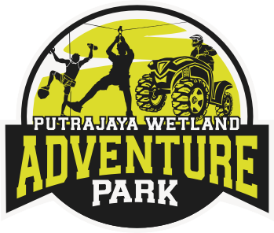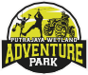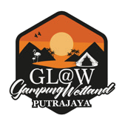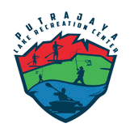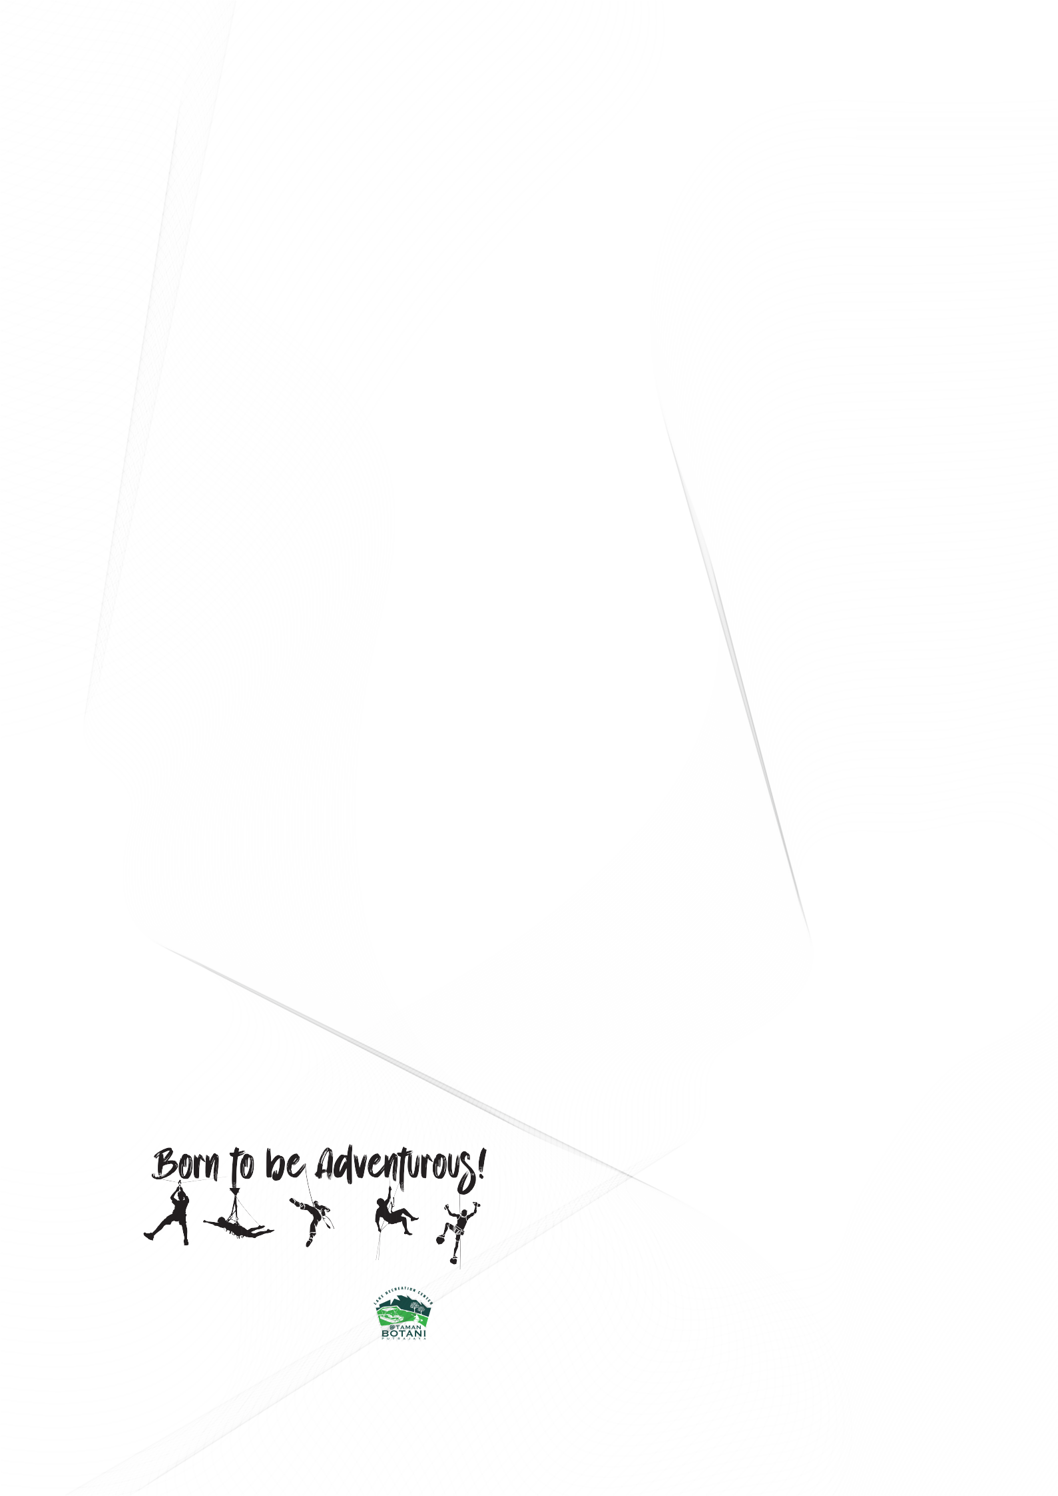

*Certificate of Participation*

We present this certificate to

<<NAME>>

<<NRIC>>

For participating in

<<ACTIVITY>>

**General Manager**

GOPENG GLAMPING PARK